UCONN MS4 MONITORING PROJECT
FIELD CHECKLIST

- Clipboard with field sheet

- Tote

- Field book

- YSI temperature/conductivity/salinity meter

- Sample bottles [500 mL qty. 10]

- Whirlpaks

- Cooler with ice packs

- Sampling pole

- Manhole cover hook

- Gloves

- Tape for labelling bottles

- Sharpie

- Partner

Mike’s cellphone#: 860-617-8945
OUTFALL IDENTIFICATION GUIDE

EB-1 EB-2 EB-3
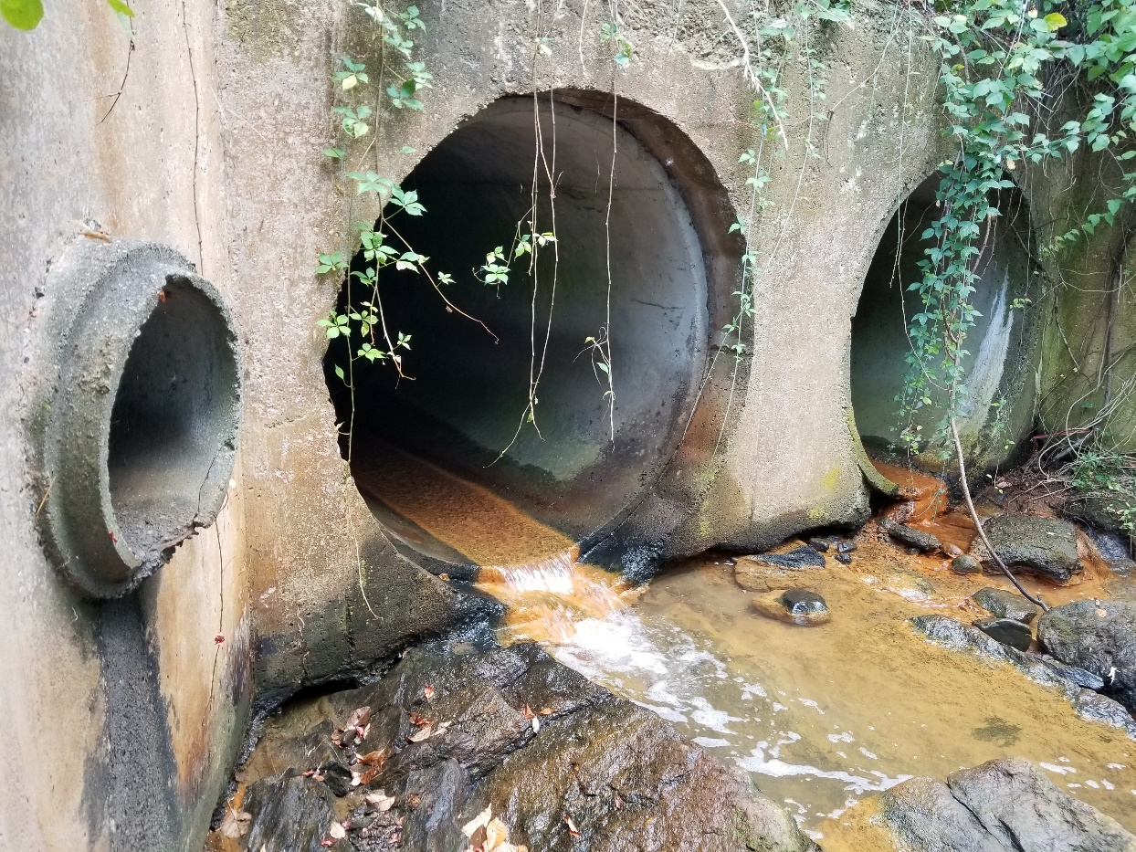

W-LOT-1 W-LOT-2

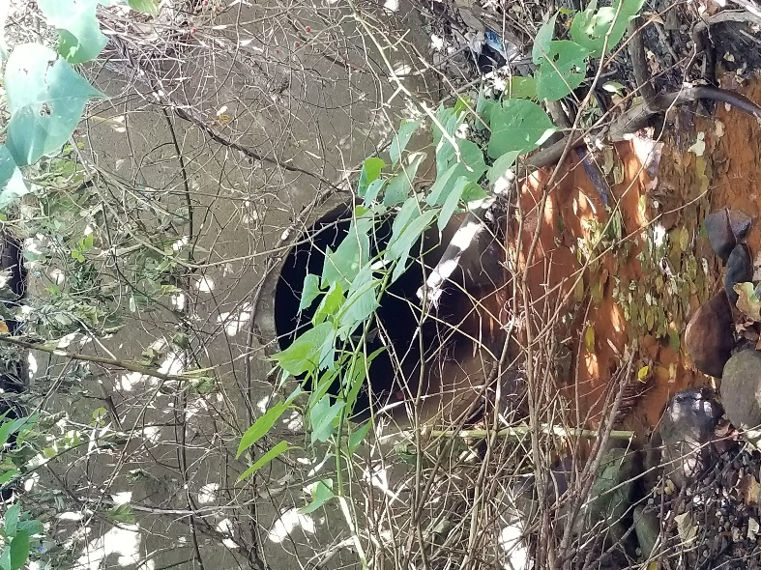
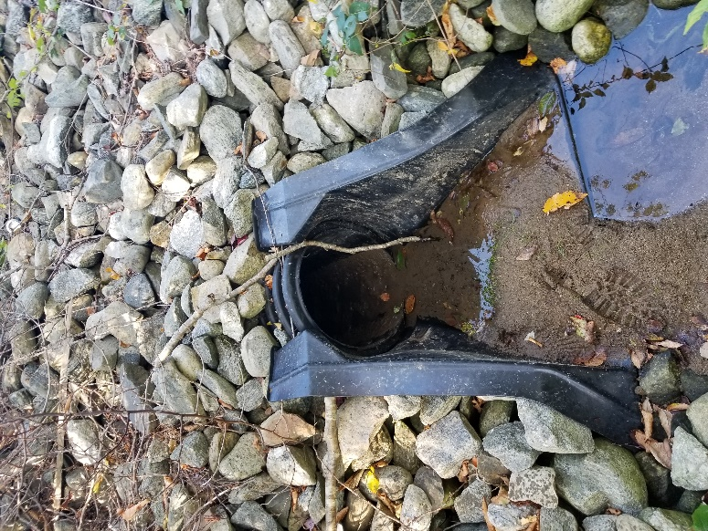

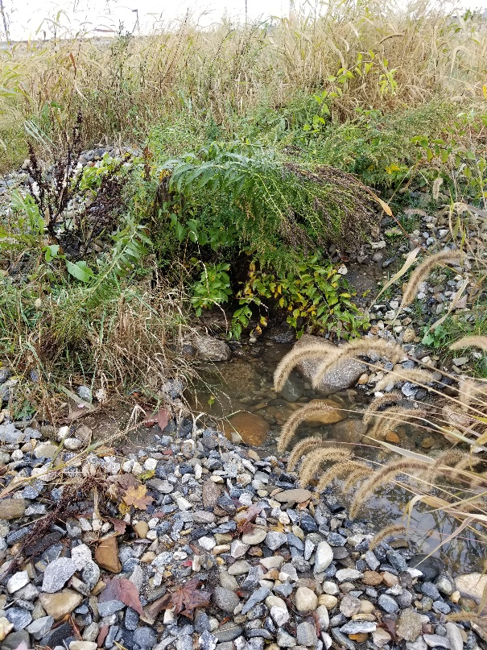
W-LOT-3 GVL-1
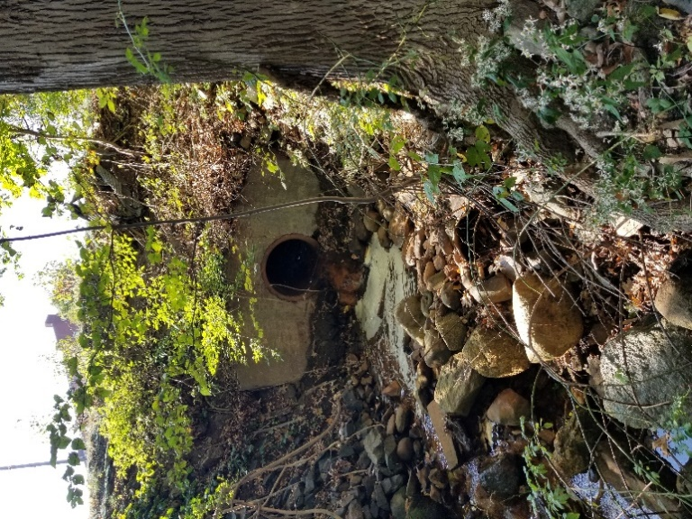

GVL-2 GVL-3
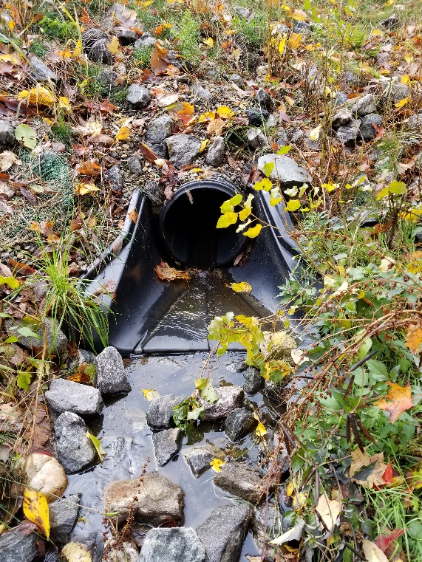
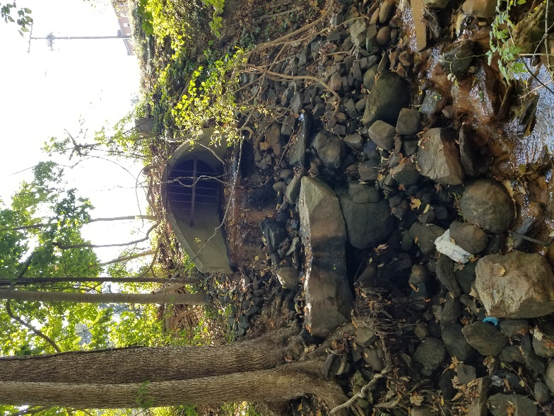

F-LOT-1 F-LOT-2
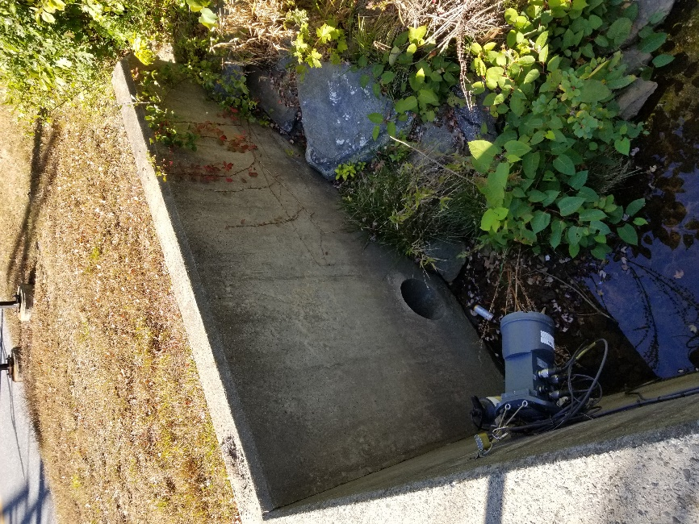
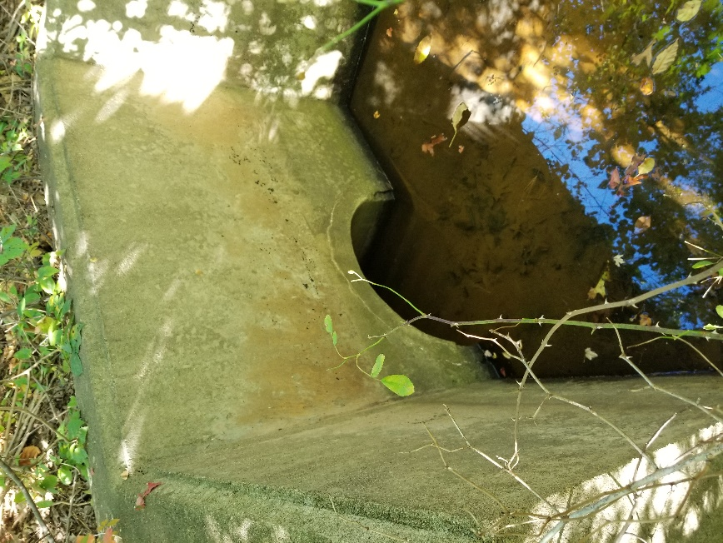

F-LOT-CB-1 F-LOT-CB-2

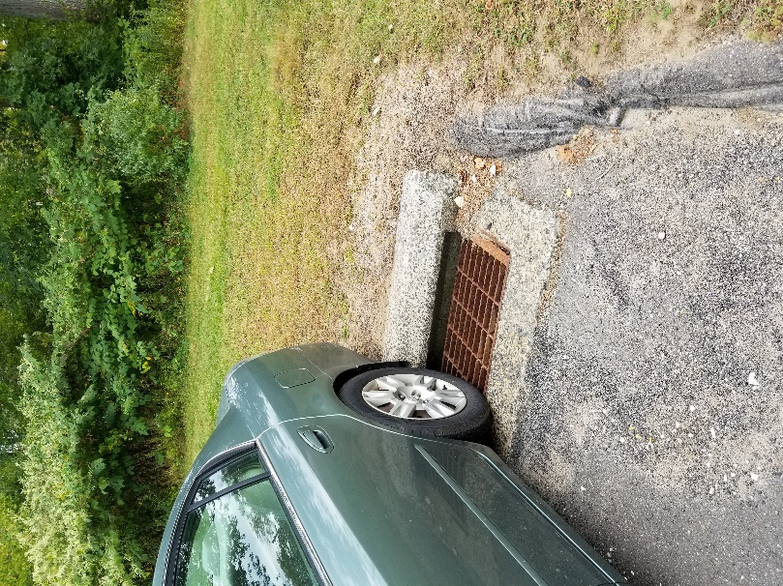
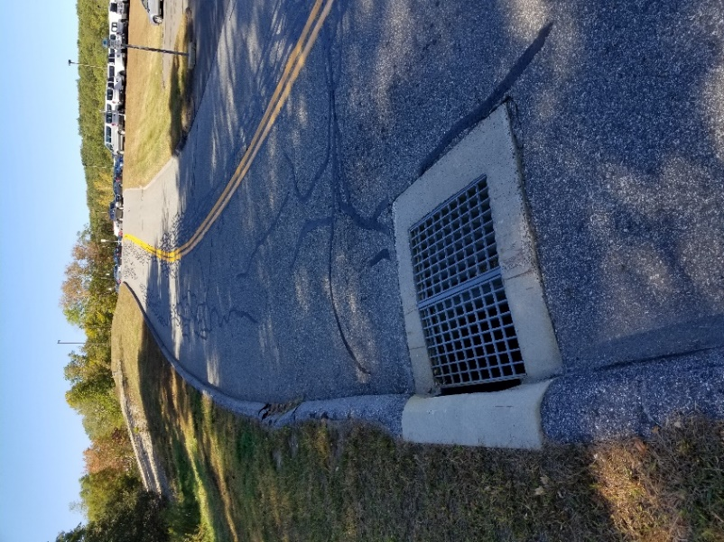

HBH MLK

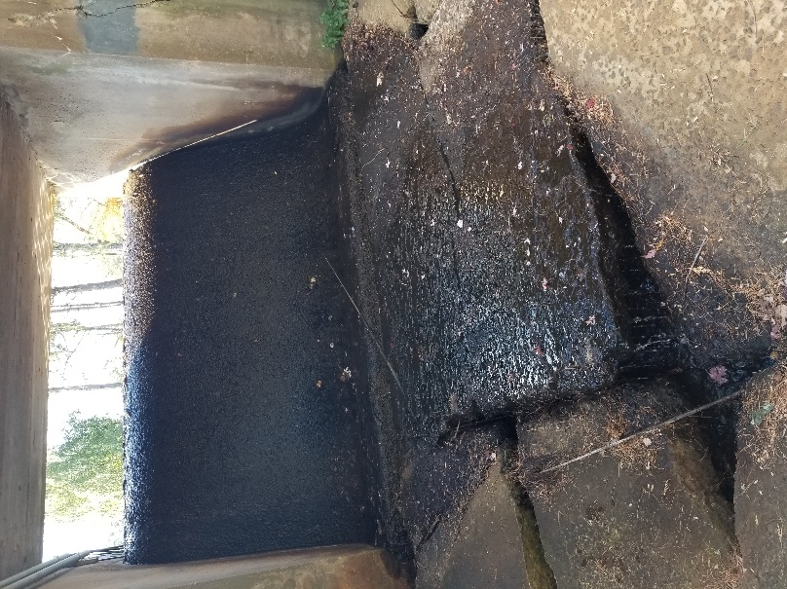
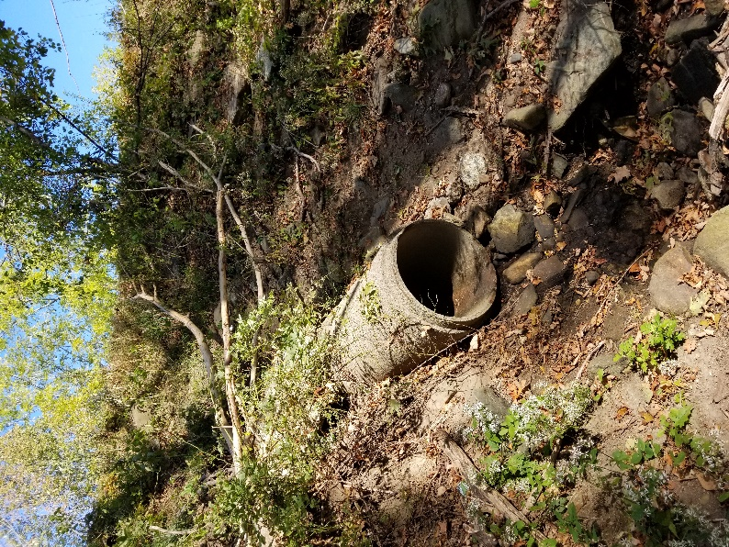

RB-1
