Manhole Inspection Form
Catchment ID | Date
Manhole ID | Rain Last 48 Hours
Street Location
Inspector

Clock Position  (1-12)  Pipe Material  (Concrete, HDPE, PVC, Ductile Iron, CMP) | Pipe Diameter  (in.) | Invert Elevation  (ft) | Upgradient Structure/Source  (MH ID, CB, Priv, Unk) | Flow  (Damp, Trickle, Moderate, High)

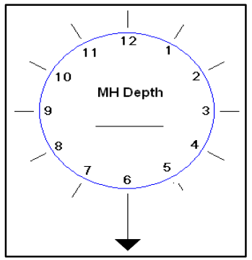

Sketch direction(s) of incoming flow
Cover Conditions: Diameter of clear opening (in.) Buried: ☐ Cannot Inspect: ☐ Cannot Locate: ☐
Evidence of Flow: ☐ Yes ☐ No If Yes, Description of Flow: ☐ Damp ☐ Trickle ☐ Moderate ☐ High

Samples Taken and Sampling Results
Temp. | Conductivity | Salinity | Chlorine
Ammonia | Surfactants | Bacteria | Pollutant of Concern
Visual Evidence of Illicit Discharge
Visual Inspection: ☐ None ☐ Floatables ☐ Pet Waste ☐Oily Sheen ☐ Sanitary Waste ☐ Algae ☐ Foam
Olfactory Evidence of Illicit Discharge
Olfactory Inspection: ☐ None ☐ Sewage Smell ☐ Musty ☐ Rotten Eggs ☐ Ammonia ☐ Petroleum
COMMENTS:

Further investigation needed? ☐ Yes ☐ No

