Changes to the Annual Report Template 2021:

Changes to the new 2021 Annual Report Template have been made with the intention of reducing / condensing the amount of information which must be reported. Municipalities and Institutions have the option to choose between using this new version of the Annual Report Template or to continue adding onto their original Annual Report, without any changes.

Overall:
- Comments within the word document template have been added. They contain the specific permit language for each requirement, as well as the corresponding permit page number
- Removal of all “Extra space for describing BMP activities” boxes
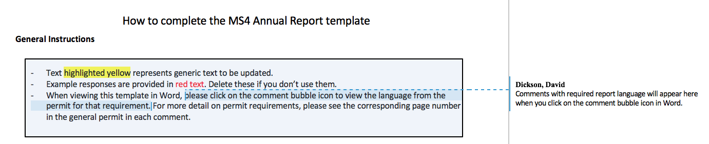

Minimum Control Measure 1:
- Table 1.3 “Details of activities implemented to educate the community on stormwater” has been removed and combined with the BMP Summary Table, resulting in the following changes:
  - Removal of the columns:
    - “Status”
    - “Date completed or projected completion date”
    - “Due”
  - Addition of the columns:
    - “Sources Used (if applicable)”
    - “Method of Distribution”
    - “Audience (and number of people reached)”
Before:
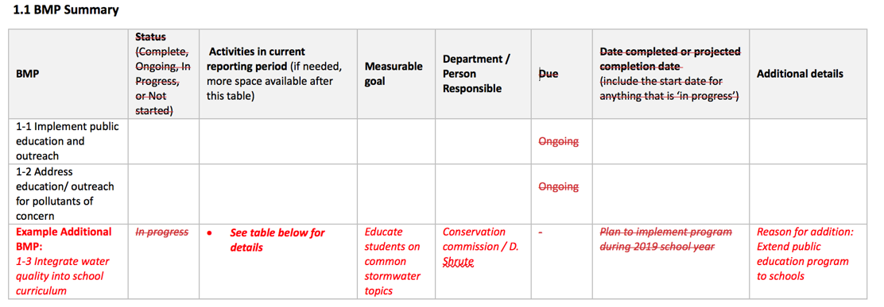
After:
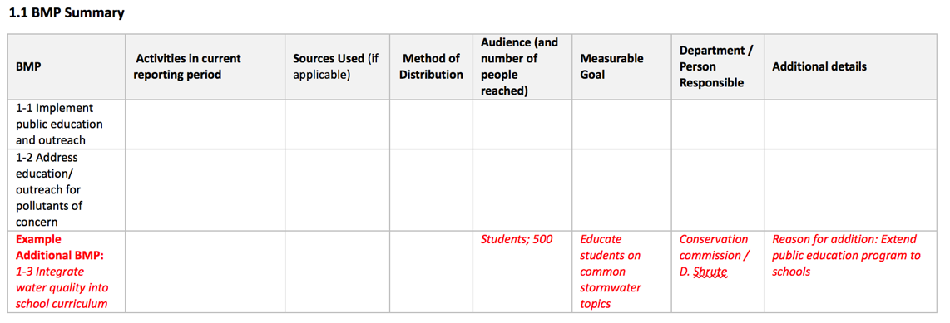

Minimum Control Measure 2:
- Table 2.3 “Public Involvement/Participation reporting metrics” has been removed and combined with the BMP Summary Table, resulting in the following changes:
  - Removal of the columns:
    - “Due”- Any dates have been added to the description of the BMP
  - Addition of the columns:
    - “Location Posted”
Before:
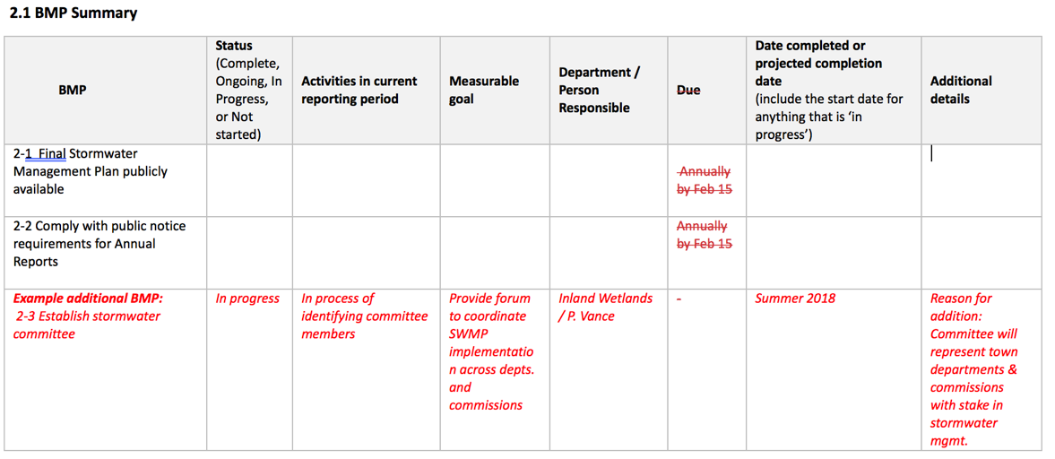
After:
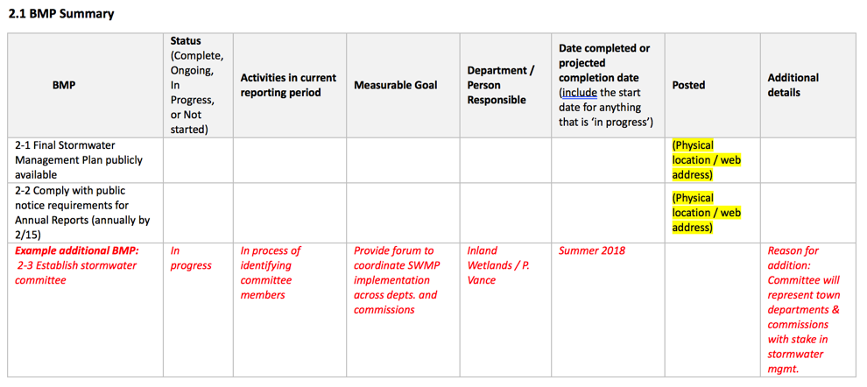

Minimum Control Measure 3:
- Within the BMP Summary Table, the following changes have been made:
  - Removal of the columns:
    - “Due” - Any dates have been added to the description of the BMP
Before:
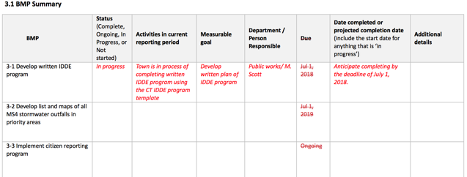
After:
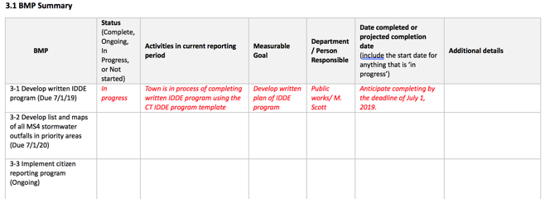
- Tables 3.3 “List of citizen reports…” and 3.4 “Provide a record of illicit discharges…” have been combined. Table 3.3 has been removed, and the title and instructions for Table 3.4 have been adjusted.

Before:
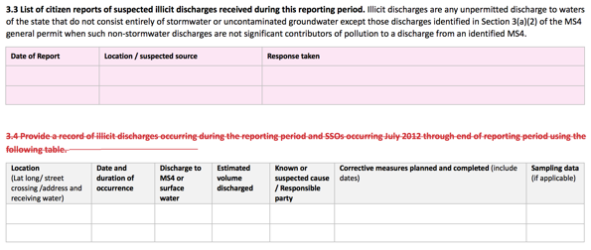

After:
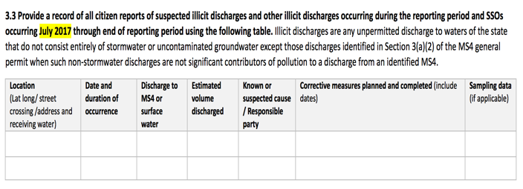
- Tables 3.5 “Briefly describe the method used” and 3.6 “Provide a summary of actions taken” have been combined. The information asked for in Table 3.6 has been put into Table 3.5. Table 3.6 now asks for a description of the method and effectiveness of said method used to track illicit discharge reports

Before:
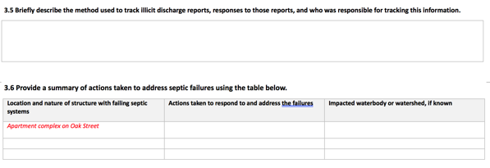
After:
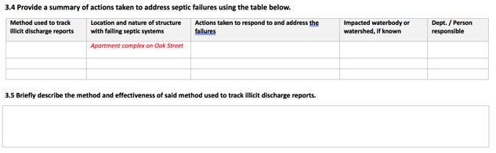

Minimum Control Measure 4:
- Within the BMP Summary Table, the following changes have been made:
  - Removal of the columns:
    - “Due” - Any dates have been added to the description of the BMP

Before:
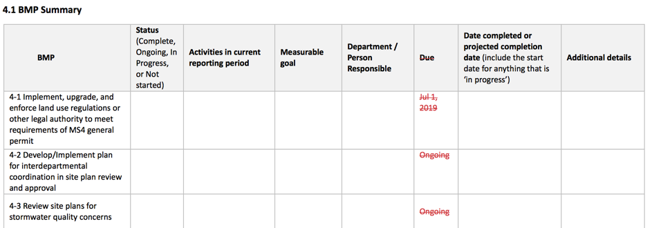
After:
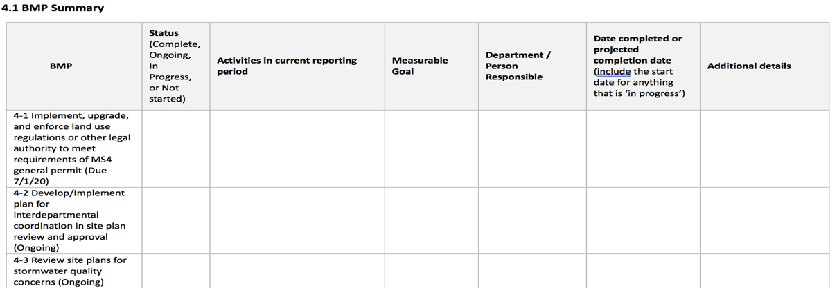

Minimum Control Measure 5:
- Within the BMP Summary Table, the following changes have been made:
  - Removal of the columns:
    - “Due” - Any dates have been added to the description of the BMP
Before:
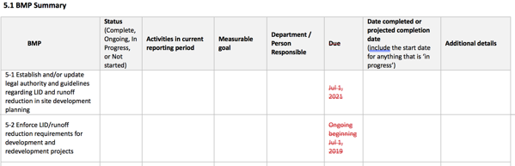
After:
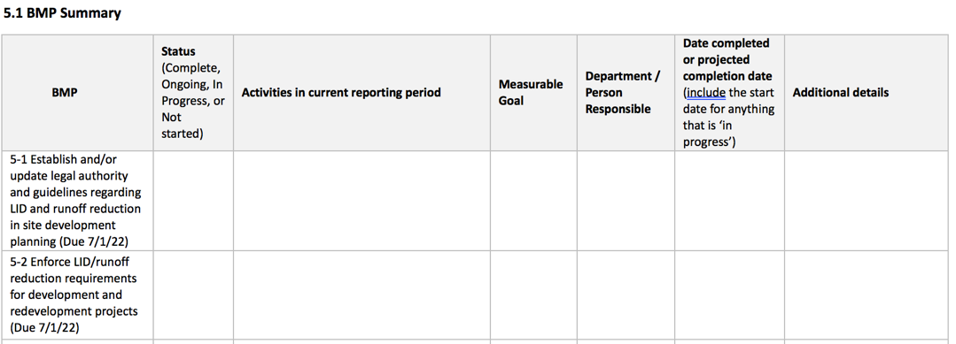

Minimum Control Measure 6:
- Within the BMP Summary Table, the following changes have been made:
  - Removal of the columns:
    - “Due” - Any dates have been added to the description of the BMP
- Removed “Describe plans for continuing the Retrofit program beyond this permit with the goal to disconnect 1% DCIA annually over the next 5 years” portion of 6.5

Before:
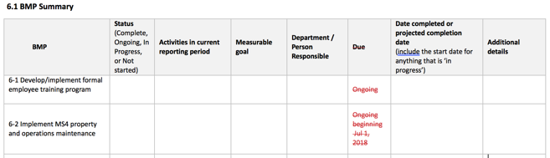
After:
