A Guide to Meeting the MS4 Post-construction Legal Authority Requirements

We compiled example regulatory language / mechanisms to help towns and institutions get started in meeting the legal authority requirements in the CT MS4 General Permit Section 6(a)(5)(A) and (B) – also known as the post-construction legal authority requirement.

This is one of the more complex sections of the permit and towns are sure to implement this requirement in many ways. The example regulatory language that follows may be adapted to fit the particular needs and circumstances in each town and by no means is any of this required to be used. Finally, the resources we’re providing don’t constitute legal advice. Please be sure to consult your lawyer!

What are the requirements?
In a nutshell, the post construction legal authority requires (to the maximum extent practicable) that MS4 towns and institutions establish a legal authority that:
- Requires developers and contractors to default to using LID practices in their projects and prioritize LID over other municipal requirements or guidance. If LID isn’t feasible on a particular site, the developer / contractor must explain why LID can’t be used in their application to the town.
The Runoff Reduction Checklist can be used or adapted to review projects for compliance with this requirement.

- Set the following minimum stormwater retention standards:
  - Water Quality Volume (WQV) for sites with less than 40% DCIA
  - ½ the WQV for sites with more than 40% DCIA
The Stormwater Retention regulatory language example below can be adapted and used to add this requirement to town regulations.

- If the relevant stormwater retention volume cannot be achieved, then two options are offered:
  - Whatever remaining volume that cannot be retained may instead be retained by an off-site mitigation project;
See example regulatory language in the Off-site Mitigation regulatory language section below.

We recommend reviewing this reference from Massachusetts: Guidance for Developing an Off-site Stormwater Compliance Program for Redevelopment Projects in Massachusetts which walks through options and considerations for setting up this type of program.

  - OR the town can collect a fee equal to the cost of implementing a retrofit project to retain the remaining water quality volume.

We also recommend reviewing Appendix E of that same helpful reference from Massachusetts: Guidance for Developing an Off-site Stormwater Compliance Program for Redevelopment Projects in Massachusetts which walks through options and considerations for setting up this type of program.

Example Stormwater Retention regulatory language

Definitions
Directly connected impervious area – the impervious area from which stormwater runoff discharges directly to waters of the state or directly to storm sewer system that discharges to waters of the state.
Low Impact Development (LID) – a site design strategy that maintains, mimics, or replicates pre-development hydrology through the use of numerous site design principles and small-scale treatment practices distributed throughout a site to manage runoff volume and water quality at the source.
Redevelopment - any construction activity (including, but not limited to, clearing and grubbing, grading, excavation, and dewatering) within existing drainage infrastructure or at an existing site to modify or expand or add onto existing buildings or structures, grounds, or infrastructure.
Retain – to hold runoff on-site to promote vegetative uptake and groundwater recharge through the use of runoff reduction or LID practices or other measures.
Runoff reduction practices – those post-construction stormwater management practices used to reduce post-development runoff volume delivered to the receiving water. Such practices include but are not limited to canopy interception, soil amendments, evaporation, rainfall harvesting, engineered infiltration, extended filtration or evapotranspiration.
Site - area extent of construction activities, including but not limited to the creation of new impervious cover and improvement of existing impervious cover (e.g. repaving or rebuilding on existing footprint without disturbing any soil would not be included).
Applicability
The requirements of this section apply to new or redevelopment projects where the extent of construction activities (site) is ½ acre or more. [If the town has established a lower threshold than the ½ acre minimum established in the Soil Erosion Control Act, then use the minimum disturbance extent regulated by the town.]

Stormwater retention standards for new and development projects
Developers and contractors seeking municipal approval for new or redevelopment projects shall, at a minimum, retain on-site the Water Quality Volume as defined in the Connecticut Stormwater Quality Manual (as amended) if the site has less than 40% Directly Connected Impervious Cover. If a redevelopment project is on a site that has greater than 40% Directly Connected Impervious Cover, they may retain on-site a lower standard of half the Water Quality Volume. The [town] may not waive these minimum retention requirements as they are required by the State Small MS4 General Permit for stormwater management of water quality protection.
In meeting these retention standards, applicants must consider the use of Low Impact Development and other runoff reduction development practices that encourage the infiltration of stormwater into the soil wherever possible prior to employing other stormwater management methods. The Runoff Reduction Checklist [indicate where found] must be completed and submitted with the applicant’s site stormwater management plan.
If due to site restrictions the applicant is unable to accommodate the on-site Water Quality Volume retention standards identified in this section, the applicant shall submit a report detailing why on-site methods are not achievable using control measures that are technologically available and economically practicable and achievable in light of best industry practice. In addition, the applicant shall either:
1) implement an off-site stormwater mitigation project in the [town or watershed] that complies with the off-site mitigation project requirements in [indicate where found]. The mitigation project should be completed [within 6 months of the original project’s completion] [there is no timeframe specified in the permit – town’s should identify a timeframe that is reasonable in terms of timeliness and achievability] and retain an equivalent amount of runoff to the portion of the Water Quality Volume that could not be retained on the original site OR
2) provide a payment in-lieu fee to the [town] based on an estimate of the cost necessary to implement a retrofit project elsewhere in town to achieve an equivalent amount of runoff reduction to the portion of the Water Quality Volume that could not be retained on the original site. [DEEP has not established a standard fee, so it is up to each town to determine how they will estimate this cost. Section E.4 of Appendix E of Guidance for Developing an Off-site Stormwater Compliance Program for Redevelopment Projects in Massachusetts offers advice on how to do this.]

Example Off-site Mitigation regulatory language

3. The application for off-site compliance for stormwater management on a redevelopment site must include:
a. A review fee in the amount of [$X] for review of the off-site compliance application
b. Stormwater management concept plan
c. Applicant information
d. Redevelopment site information
e. Documentation of meeting on-site compliance to the maximum extent practicable (MEP)
f. Water volume calculations using the procedures established in the Connecticut Stormwater Quality Manual, or other equivalent method preapproved by [town], OR pollutant removal calculations consistent with EPA Region 1’s BMP Performance Extrapolation Tool, other BMP B-2 performance evaluation tool provided by EPA Region 1, or federally or state approved BMP design guidance or performance standards.
4. To be eligible for off-site compliance on a redevelopment site, the Applicant must demonstrate to the satisfaction of [town] that on-site compliance was met to the MEP.
5. Off-site mitigation projects must meet the following conditions:
a. The off-site mitigation project must be in the same [watershed/town] as the original project, and on existing impervious surface not expected to be the subject of redevelopment in the next 5 [or more] years, as approved by [town].
b. [town] shall, at its discretion, identify priority areas within the [watershed] in which off-site mitigation projects may be completed.
c. Off-site mitigation must be for retrofit or redevelopment projects, and cannot be applied to new development.
d. In all cases, land rights, access agreements or easements, and a maintenance agreement and plan shall be developed to ensure long-term maintenance of any off-site mitigation project prior to approval of the off-site mitigation proposal.
e. Installation of the off-site mitigation project shall be completed: (a) within three (3) years from the date that the stormwater management design plan is approved, or (b) prior to full completion of the new development or redevelopment project related to the off-site mitigation project, whichever of (a) or (b) is earlier.
6. All requirements in Sections [list sections] for on-site stormwater management shall also apply to off-site mitigation projects. These requirements include but are not limited to a stormwater management design plan, inspections, maintenance, and performance bonds.
NOTE to MS4s: Section 6 is one model for ensuring that off-site mitigation projects are held to the same requirements as on-site projects. Using this approach, the new off-site ordinance/bylaw simply references the appropriate sections of the broader ordinance/bylaw.

Runoff Reduction Checklist

Due to individual site differences, not all checklist items will apply to every project. Check items to be applied and explain why any items will not be used including the site’s limitations and why implemented measures represent the maximum extent achievable. If the appropriate volume of runoff cannot be retained onsite, provide the retention volume to be achieved and describe the proposed measures to provide additional stormwater treatment for sediment, floatables and nutrients above the alternate volume up to the water quality volume.
For more details on LID practices and how to implement them please refer to the Connecticut Stormwater Quality Manual.

- Assess Natural Resources
- Identify natural resources and site constraints on the plans.
Constraints include available space, soil infiltration characteristics, water table, slope, rock outcrop, drainage patterns, sunlight and shade, wind, critical habitat, existing buildings, infill opportunities, circulation and underground utilities.
Natural resources include wetlands, rivers, streams, flood hazard zones, meadows, agricultural land, tree lines, slopes [identified with 2 foot contours], soil types, exposed ledge & stone walls.
- Delineate the watershed and micro-watershed areas on the plan. Take into account previously modified drainage patterns, roads, infill opportunities, and stormwater conveyance systems.
- Design development to avoid or minimize changes to the natural existing drainage patterns and avoid critical water courses, streams, floodplains, wetlands, steep slopes and where possible, soils with high infiltration rates.
- Maintain vegetated buffers along waterways.
- Assess onsite soils to determine suitability for septic and stormwater infiltration and identify on plans.
- Include soil infiltration rate/permeability on plan:
See sheet#_____________________________________________
- Is the property shown on the latest copy of CT DEEP State and Federal Listed Species and Significant Natural Communities Map as listed in the Natural Diversity Data Base (NDDB)? If so, provide a copy of the CT DEEP NDDB request form and CT DEEP reply letter.
For items not checked, please attach explanation of why that item was not appropriate or possible for your project, or any other pertinent information.

- Preserve Open Space
- Calculate the percent of natural open space covering the site. Natural open space includes woodlands, riparian corridors, areas contiguous to wetlands and other hydrologically sensitive and naturally vegetated areas.
Percent=______________
- An open space or cluster subdivision design has been used.
- Delineate open space/common areas.
- Retain open space a natural condition.
- Avoid removal of existing trees.
- Preservation areas shall be located within an acceptable conservation easement instrument that ensures perpetual protection of the proposed area. The easement must clearly specify how the natural area vegetation shall be managed and boundaries will be marked. [Note: managed turf (e.g., playgrounds, regularly maintained open areas) is not an acceptable form of vegetation management.]
- Preservation areas shall have a minimum contiguous area of 10,000 square feet or in the case of stream buffers must maintain a 50-foot set back from the jurisdictional wetland edge along the entire length of stream through the property of concern. Areas of smaller size may be incorporated for disconnection of impervious surface, but will be considered as open space in good condition.
- Reduce setbacks, frontages, and right-of-way widths where practicable. Where practicable, reduce building setbacks to 20-30 feet and reduce frontages to 60 feet.
For items not checked, please attach explanation of why that item was not appropriate or possible for your project, or any other pertinent information.

- Minimize Land Disturbance
- The proposed building(s) is/are located where development can occur with the least environmental impact.
- Limits of disturbance should be no more than: area of the building pad and utilities (e.g. onsite wastewater treatment systems and wells) plus 25 feet; and area of a roadbed and shoulder plus 9 feet (not intended to limit lawn areas).
- Disturbance areas have been delineated to avoid unnecessary clearing or grading.
- Native vegetation outside the immediate construction areas remains undisturbed or will be restored.
- Plan includes detail on construction methods and sequencing to minimize compaction of natural and future stormwater areas.
- Maintain existing topography and drainage divides.
- Avoid removal of existing trees.
- Limit turf areas to those areas necessary to construct buildings, utilities, stormwater management measures, parking, access ways, reasonable lawn areas and contouring necessary to prevent future site erosion.

For items not checked, please attach explanation of why that item was not appropriate or possible for your project, or any other pertinent information.

- Reduce and Disconnect Impervious Cover
  - Keep impervious surfaces to the minimum extent practicable, using the following methods (check which methods were used):
    - Minimize road widths [coordinate any modifications of standard with existing road standards]
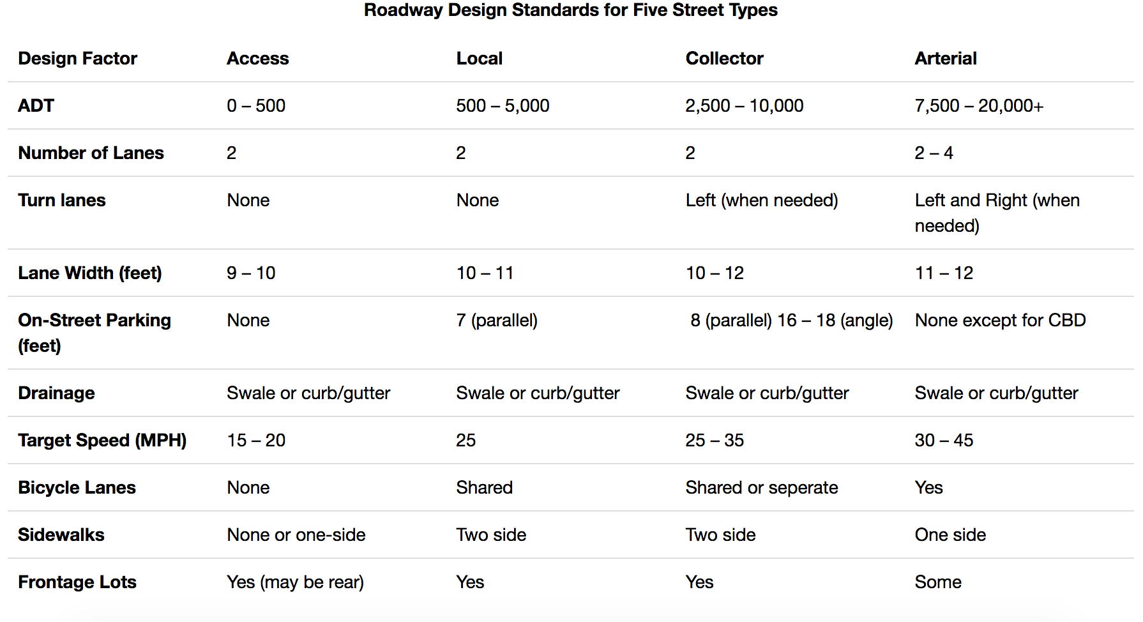

    - Minimize driveway area
    - Minimize sidewalk area
    - Minimize cul-de-sacs
      - Where cul-de-sacs are necessary radii should be no more than 30 feet. Alternatives such as hammerheads, jug handles and donuts should also be considered.
      - Incorporate Parking lot islands where possible. They should:
        - Be at least 8 feet wide.
        - Be constructed with sub-surface drainage.
        - Incorporate compaction resistant soil.
    - Minimize building footprint
      - Where practicable, reduce building setbacks to 20 - 30 feet and driveway widths to 18 feet.
      - Where practicable, reduce frontages to 60 feet.
      - Avoid installing roof drains.
    - Minimized parking lot area
      - Minimize parking space dimensions
      - Use parking decks
      - Use shared parking in mixed-use areas
  - Disconnect impervious surfaces from the stormwater system to the extent practicable and direct flow to appropriate pervious areas. Pervious areas may be LID practices, or uncompacted turf areas.
For items not checked, please attach explanation of why that item was not appropriate or possible for your project, or any other pertinent information.
- LID Practices Installed
- Sheet flow is used to the maximum extent possible to avoid concentrating runoff.
- Vegetated swales have been installed adjacent to driveways and/or roads in lieu of a curb and gutter stormwater collection system.
- Rooftop drainage is discharged to bioretention/rain gardens.
- Rooftop drainage is discharged to drywell or infiltration trench.
- Rain water harvesting methods such as rain barrels or cisterns have been installed to manage roof drainage.
- Driveway, roadway, and/or parking lot drainage is directed to bioretention/rain gardens.
- Cul-de-sacs include a landscaped bioretention island.
- Vegetated roof systems have been installed, if appropriate.
- Pervious pavements have been installed, if appropriate.
- In areas with on-site sewage disposal systems, coordinate with health official to confirm infiltration measures are sized, located and constructed in a manner consistent with the CT DPH’s Technical Standards for Subsurface Sewage Disposal Systems, Section 19-13-B100A.
For items not checked, please attach explanation of why that item was not appropriate or possible for your project, or any other pertinent information.

